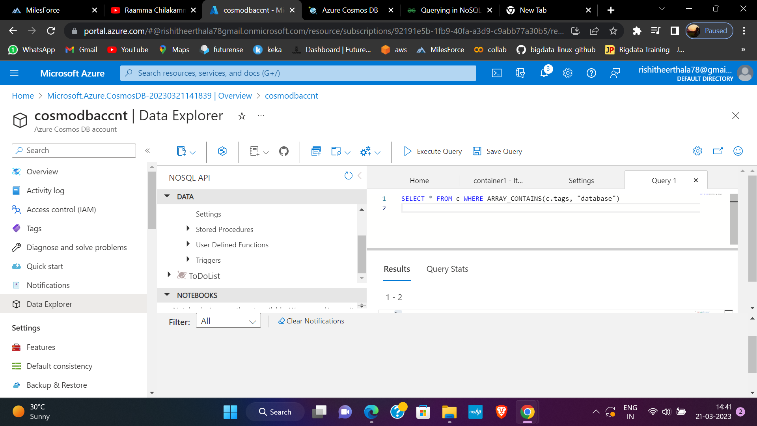

SELECT * FROM c WHERE ARRAY_CONTAINS(c.tags, "database")

------------------------------------------------------------------------------------------

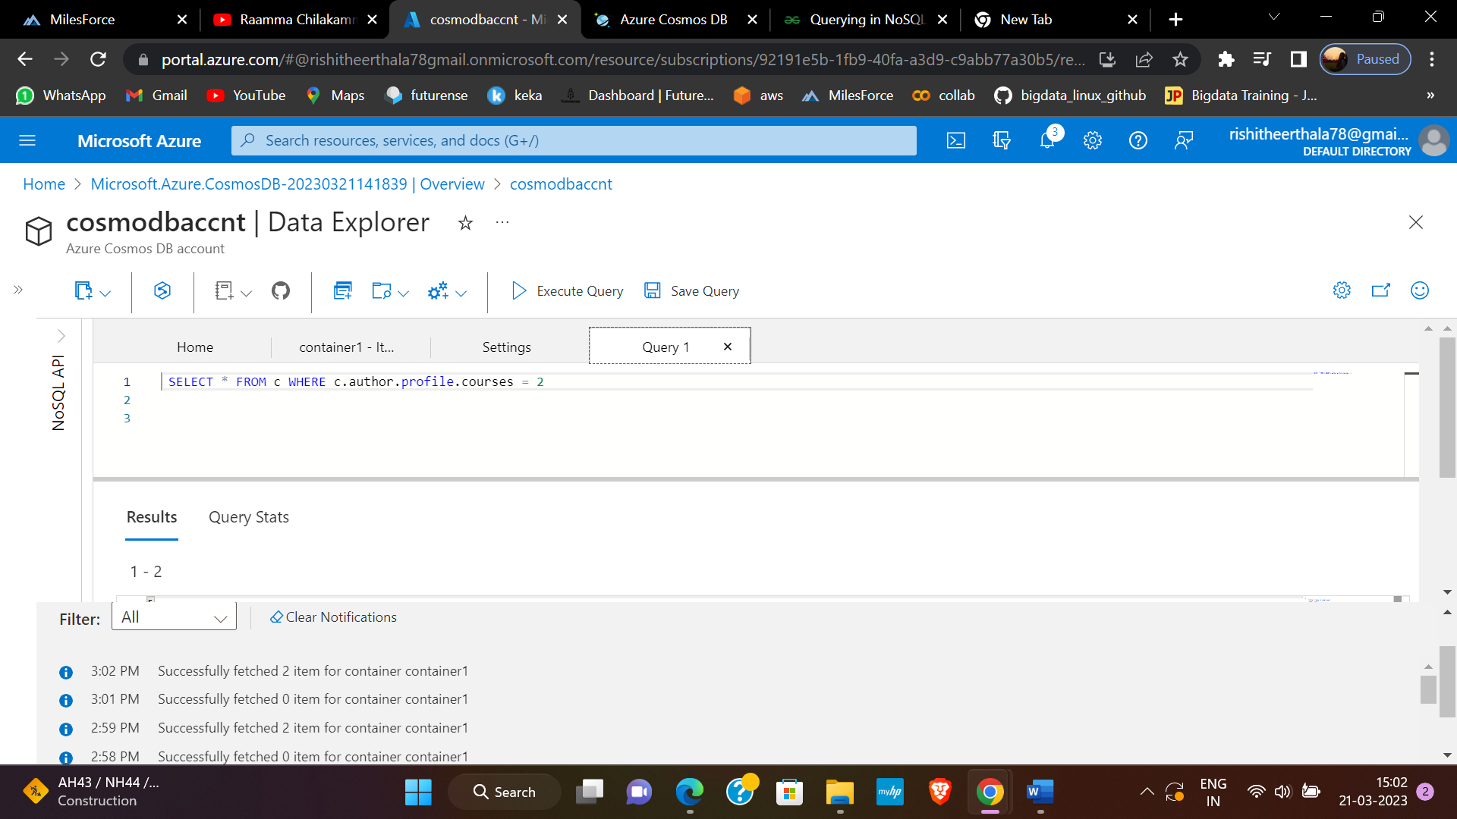

 SELECT * FROM c WHERE c.author.profile.courses = 2

-----------------------------------------------------------------------------------------------------------------------------

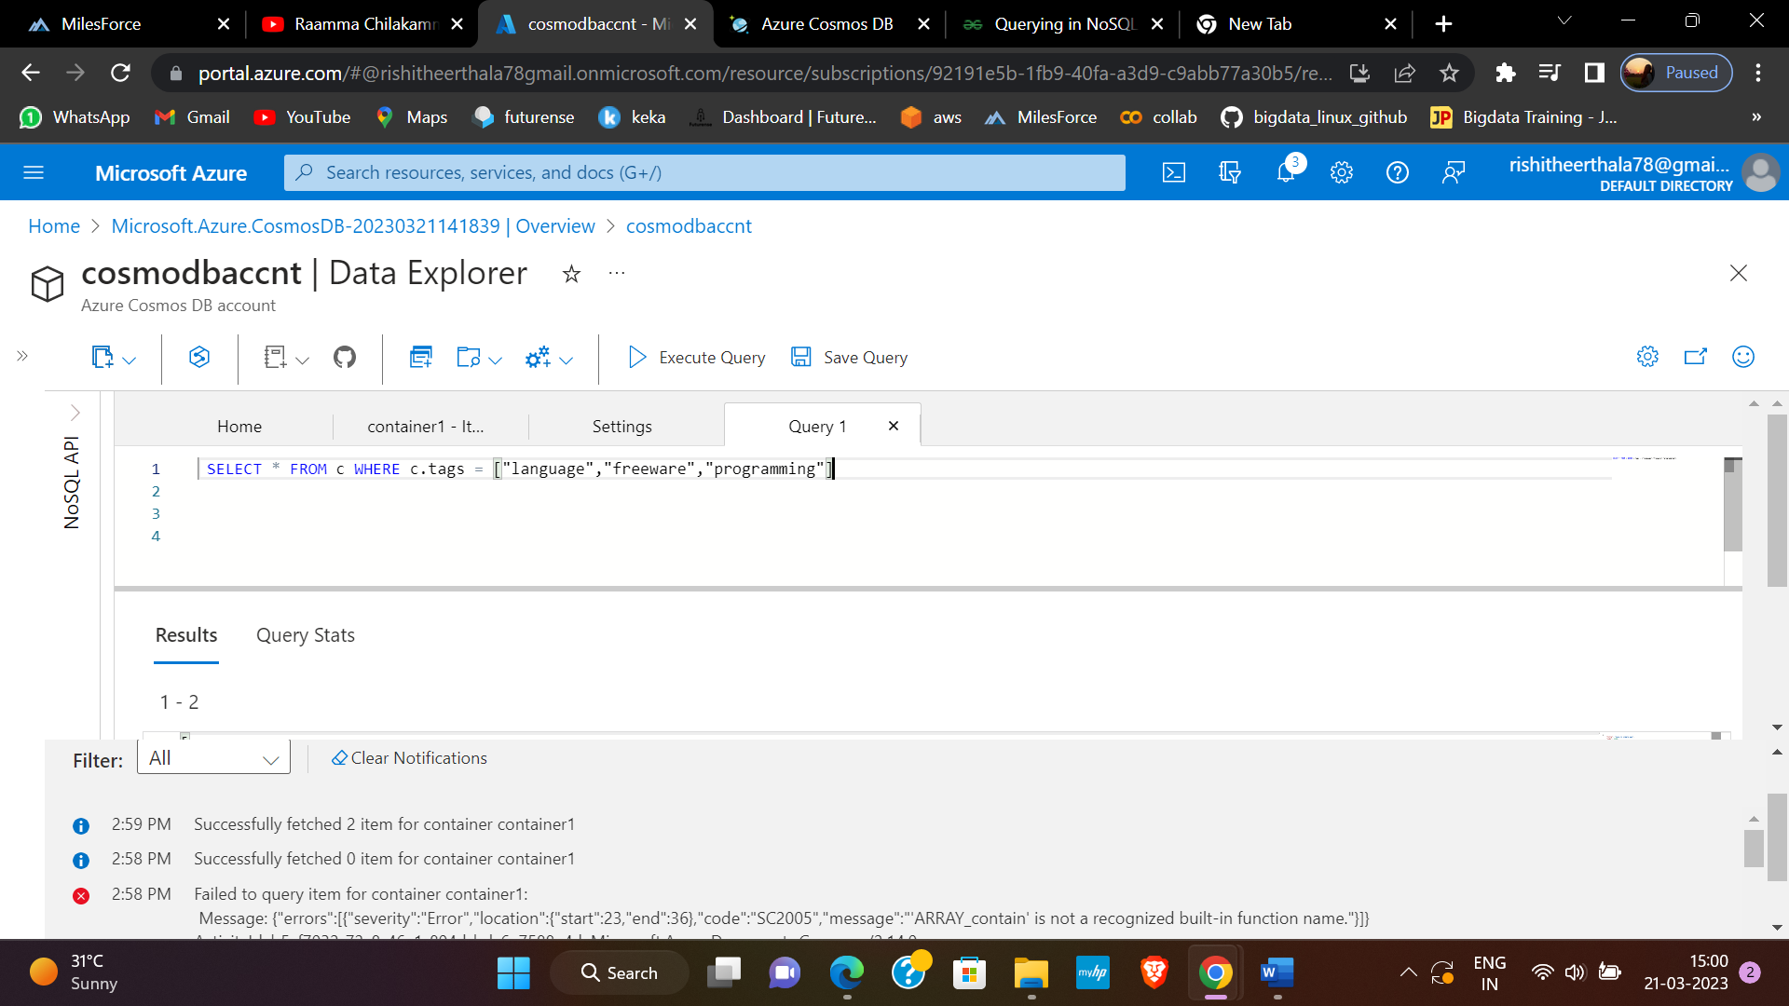

 SELECT * FROM c WHERE c.tags = ["language","freeware","programming"]

-------------------------------------------------------------------------------------------

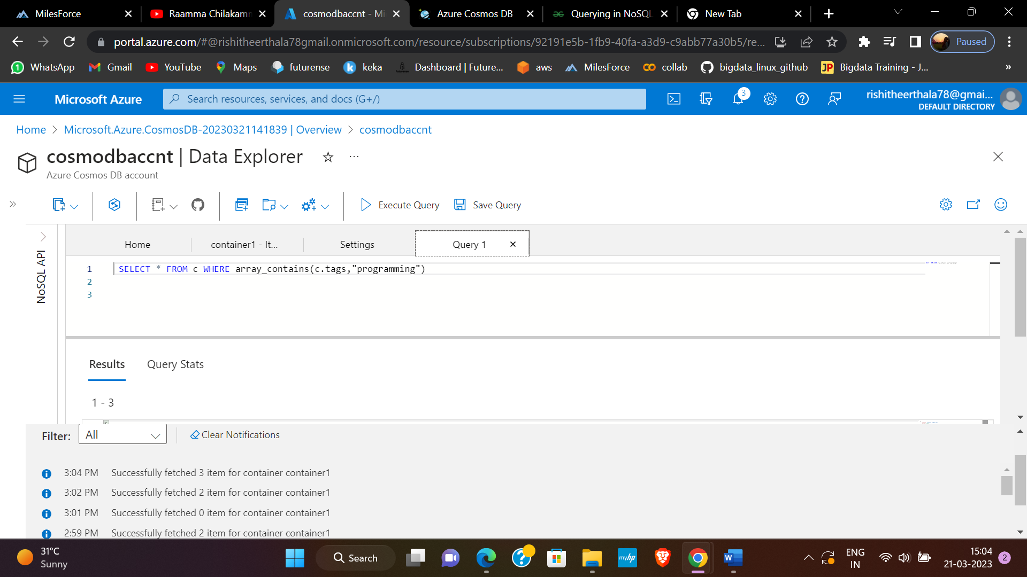

 SELECT * FROM c WHERE array_contains(c.tags,"programming")

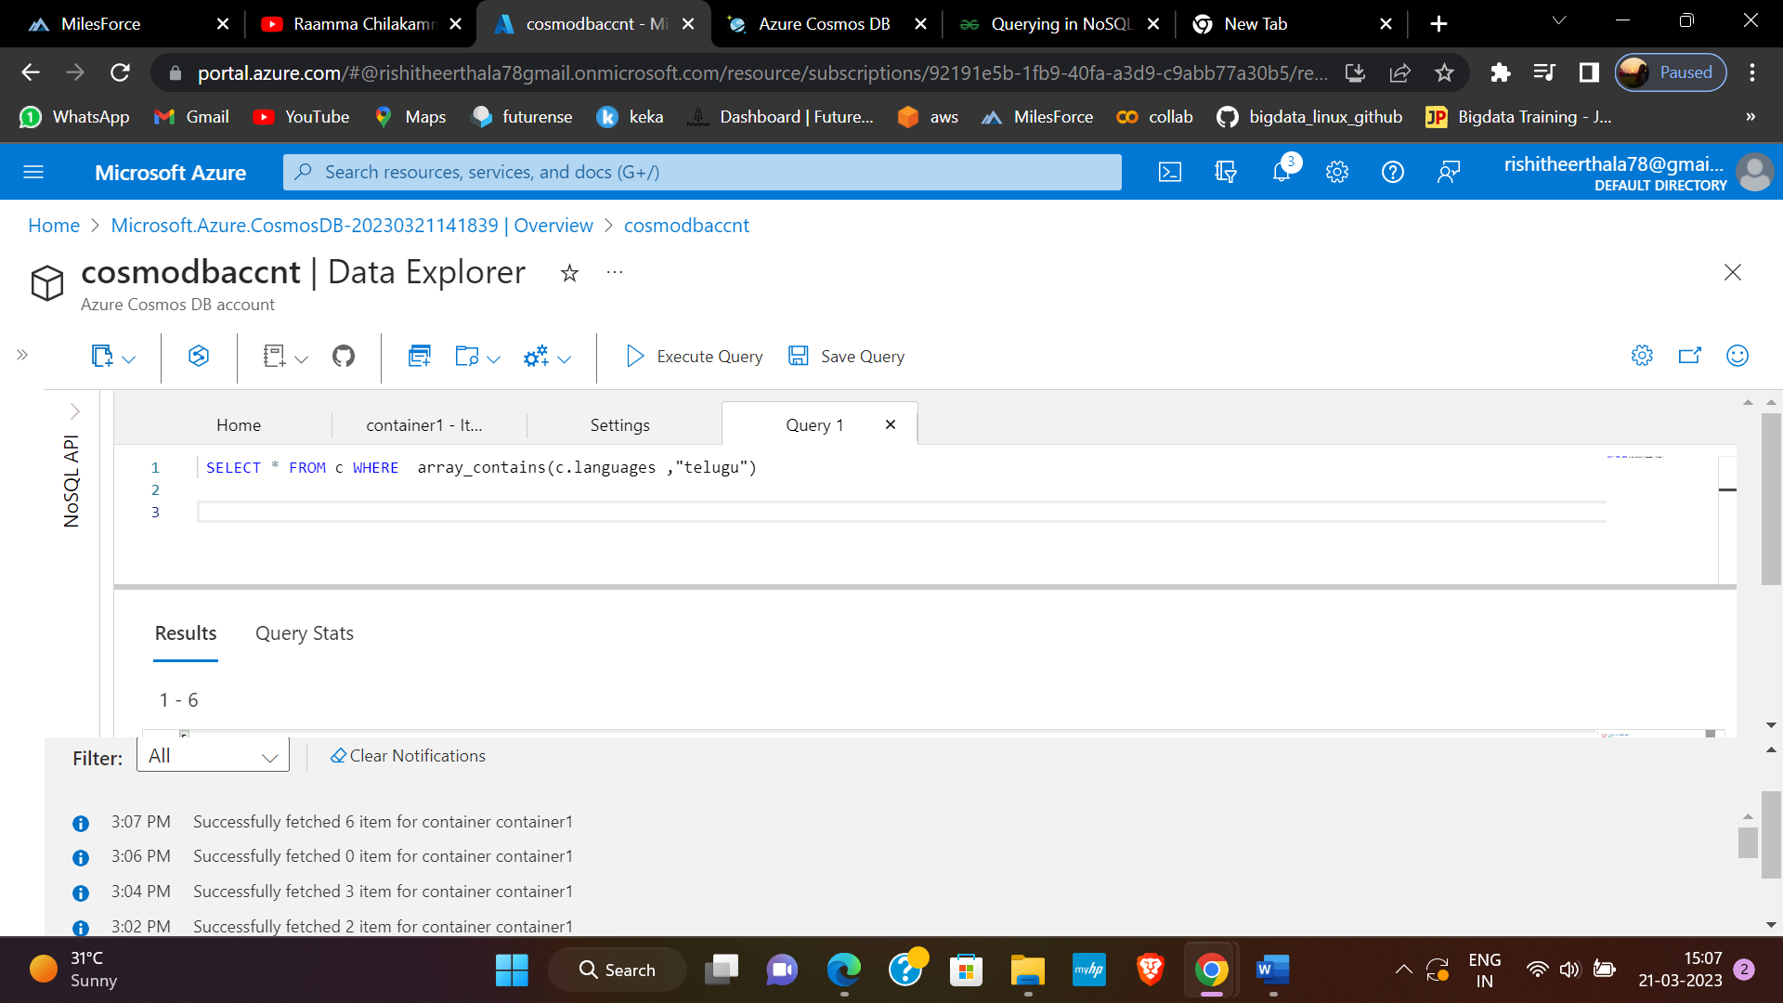

 SELECT * FROM c WHERE  array_contains(c.languages ,"telugu")

 SELECT * FROM c

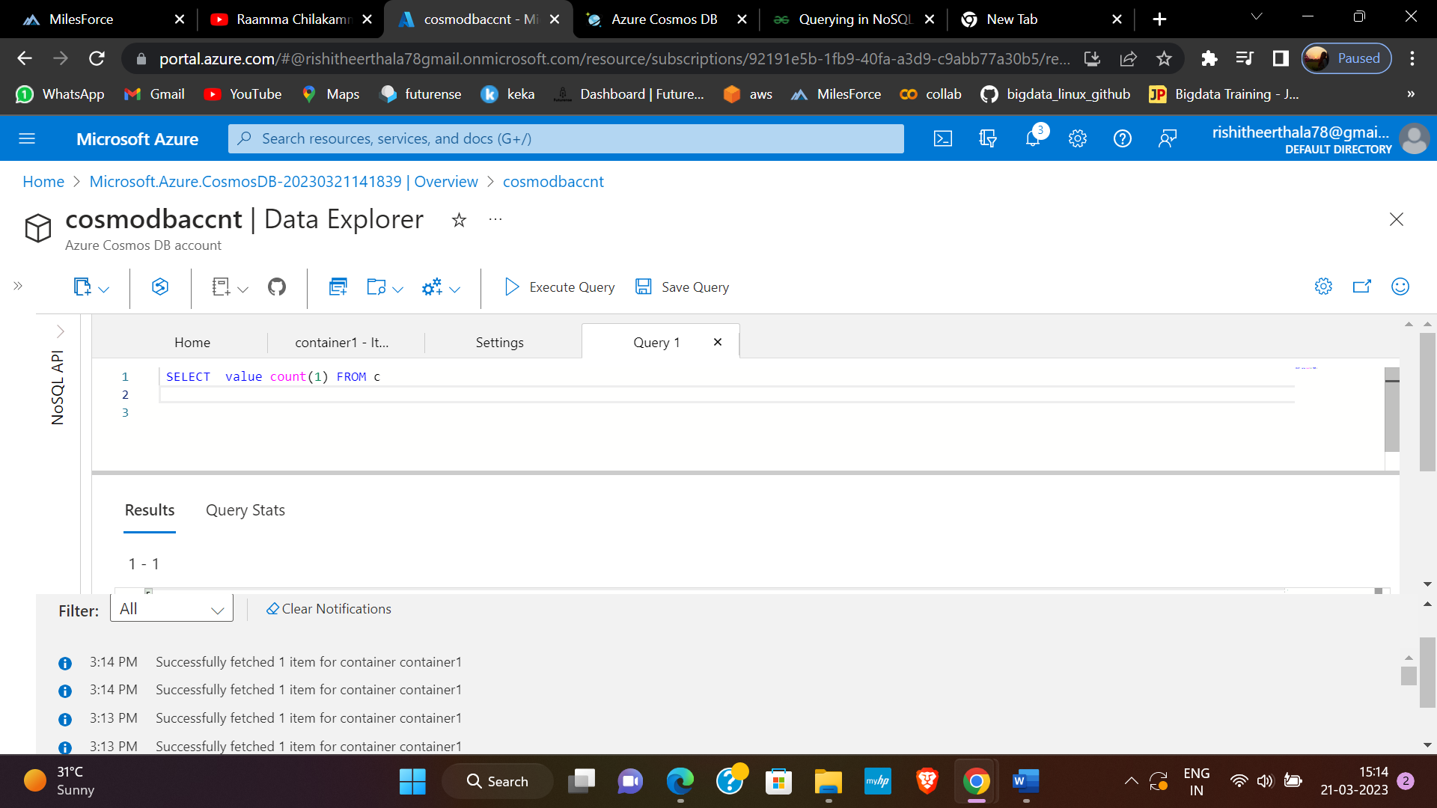

 SELECT  value count(1) FROM c

select top 1 * from c

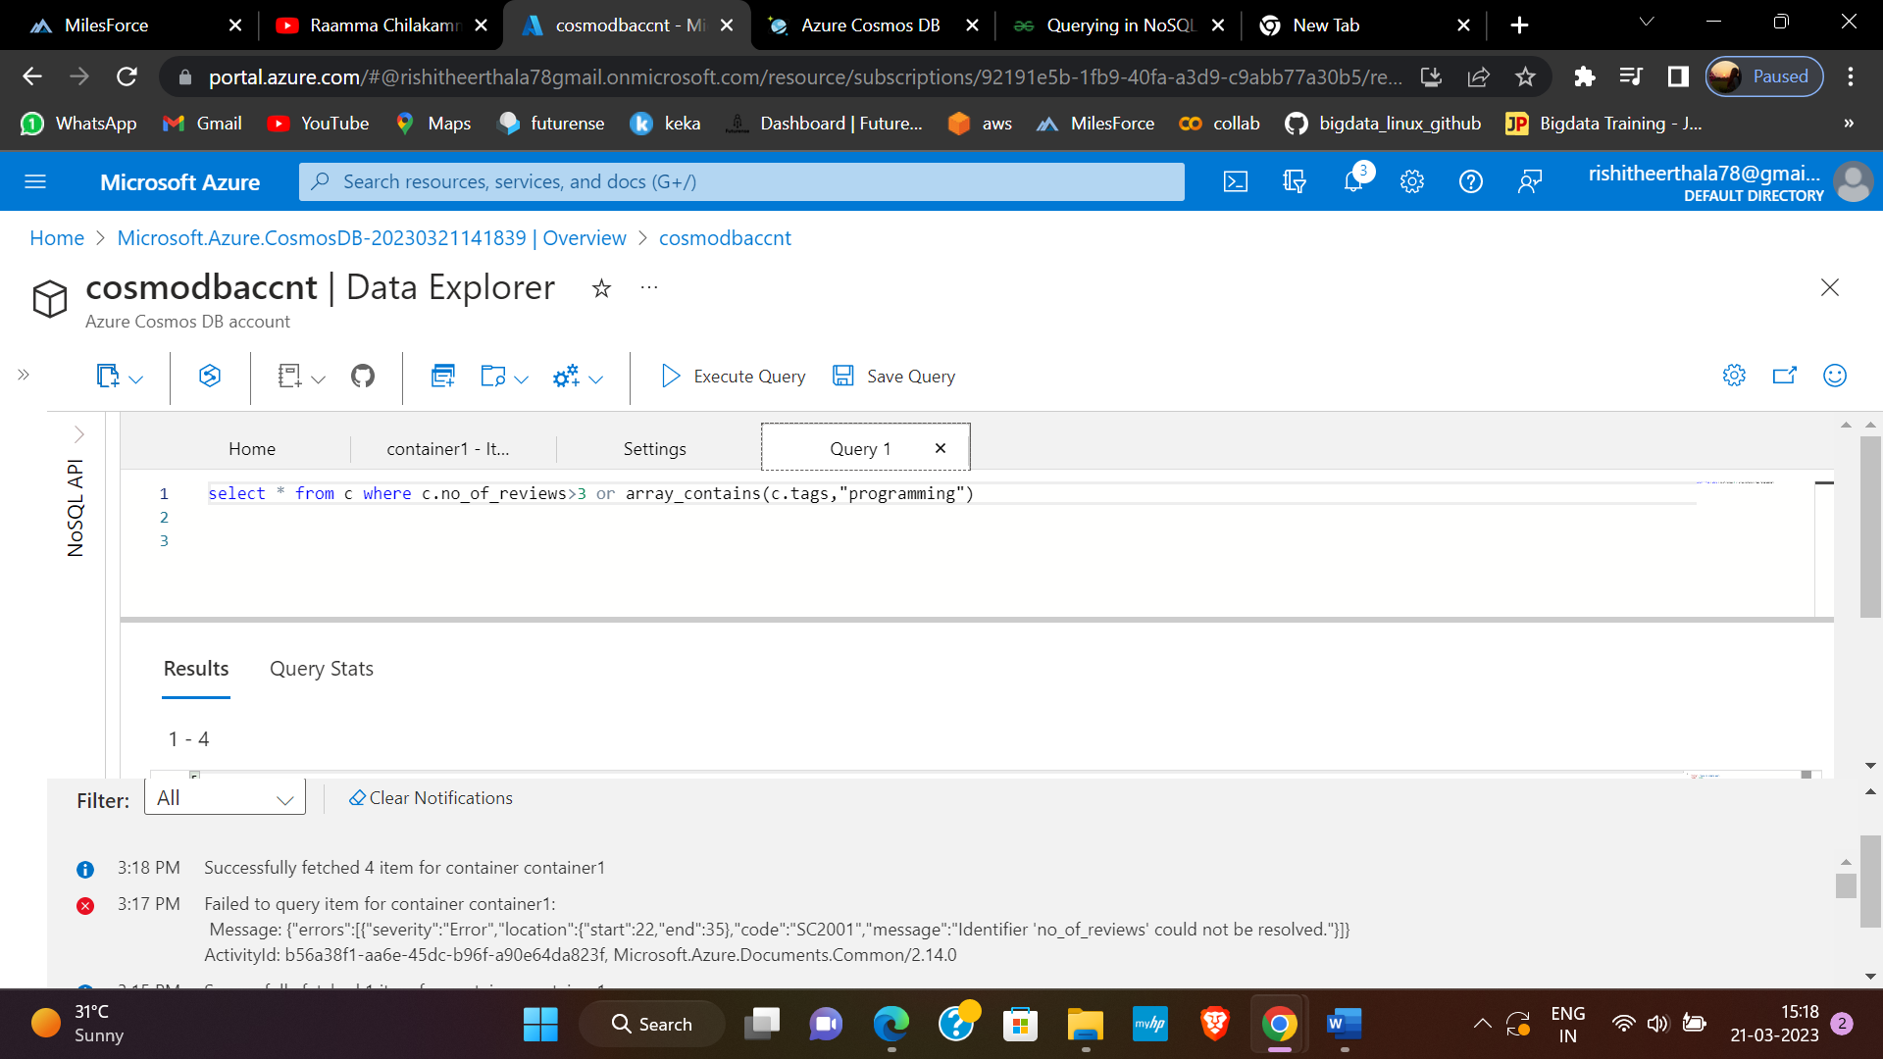

select * from c where c.no_of_reviews>3 or array_contains(c.tags,"programming")

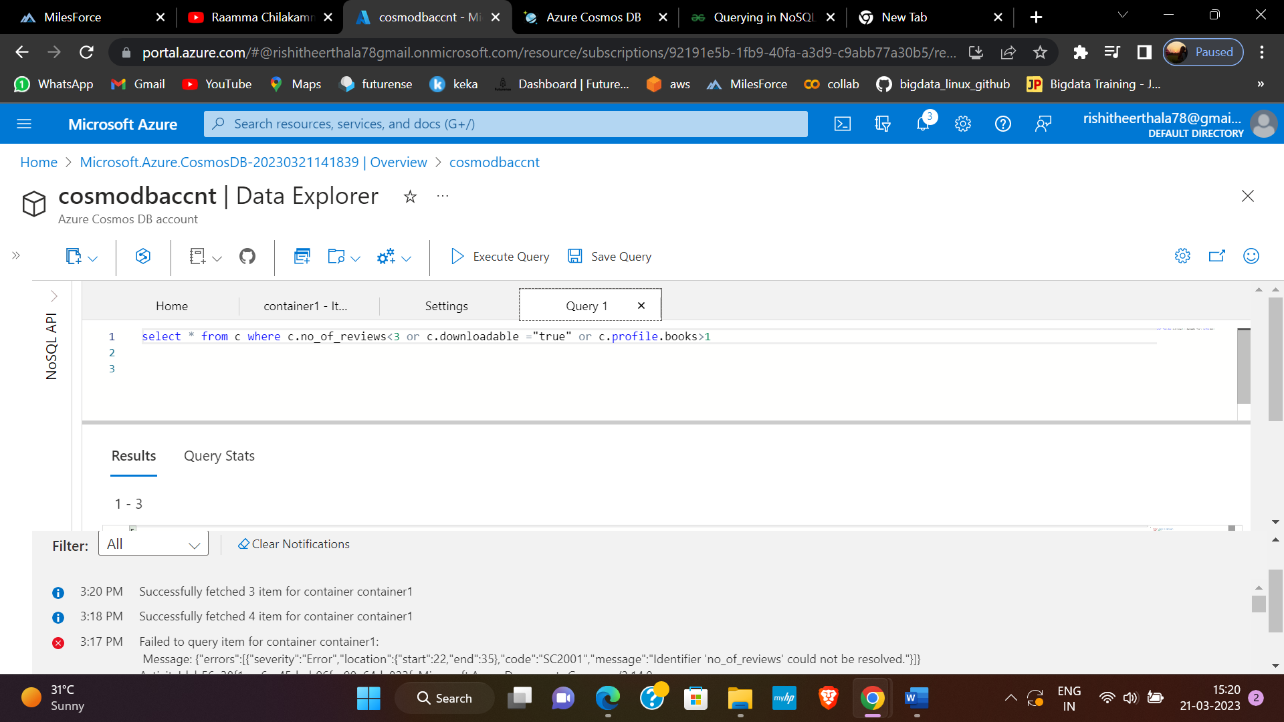

select * from c where c.no_of_reviews<3 or c.downloadable ="true" or c.profile.books>1

select * from c where c.no_of_reviews<3

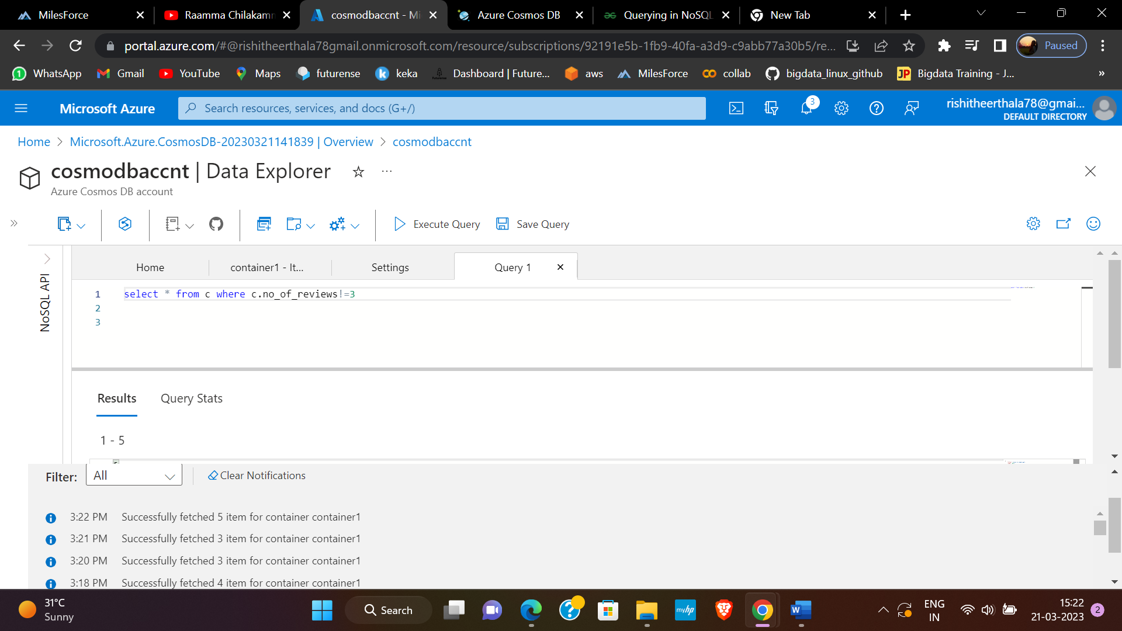

select * from c where c.no_of_reviews!=3

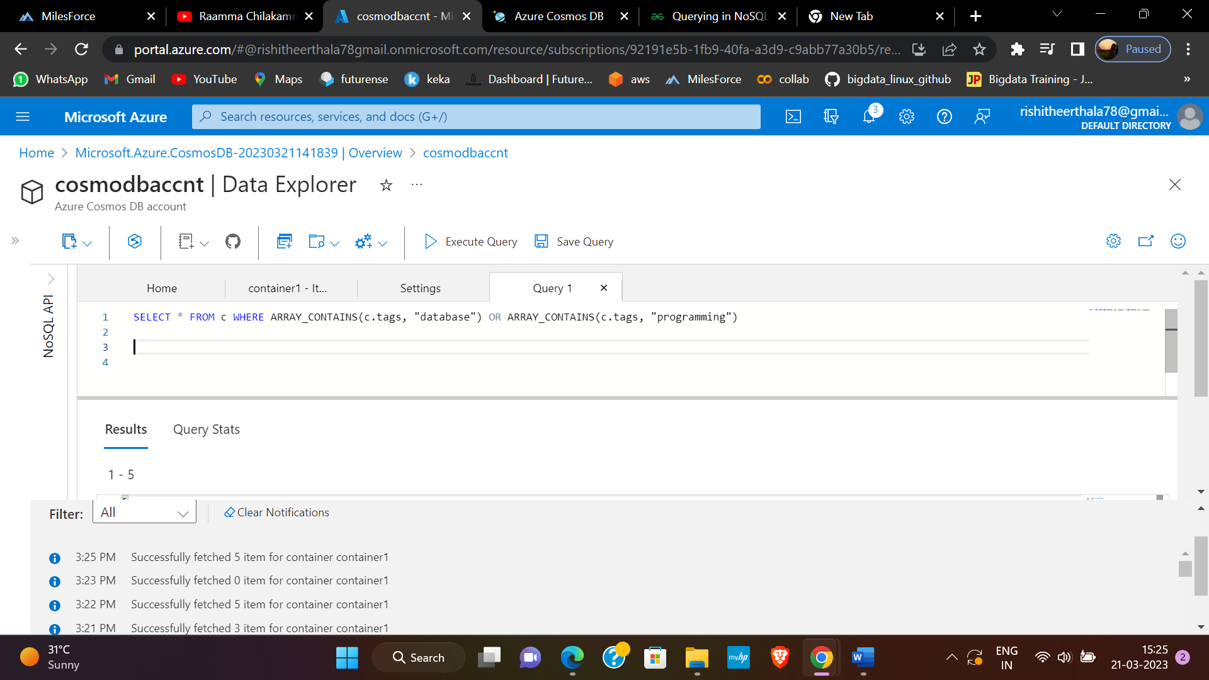

SELECT * FROM c WHERE ARRAY_CONTAINS(c.tags, "database") OR ARRAY_CONTAINS(c.tags, "programming")